Dear DPAC and institution Financial Aid representative,

The purpose of this communication is to explain the update to the 2015 Financial Aid Specification that documents the Financial Aid submission file that we will receive from you in September.

As many of you are aware, the inclusion of “semester” information in the financial aid file submitted last year did not produce the additional information desired, and also caused issues for some institutions because of the way financial aid is awarded in summer academic terms.

To remedy this situation, I have reviewed the outputs the HEPC wants to develop with the included semester information, and have spoken to several institutions about how they set up their financial aid years in Banner.

To move forward, and continue to meet the HEPC statutory reporting requirements for financial aid information while at the same time trying to make the financial aid report easier for institutions to prepare – goals that are not often complementary – the existing “semester” field will be re-purposed and a “student submission year” field will be added (further details explained later in this document).

Furthermore, the reporting period for the financial aid submission will be the institution’s “Aid Year” as defined in their Banner (see the ROAINST form, example below).

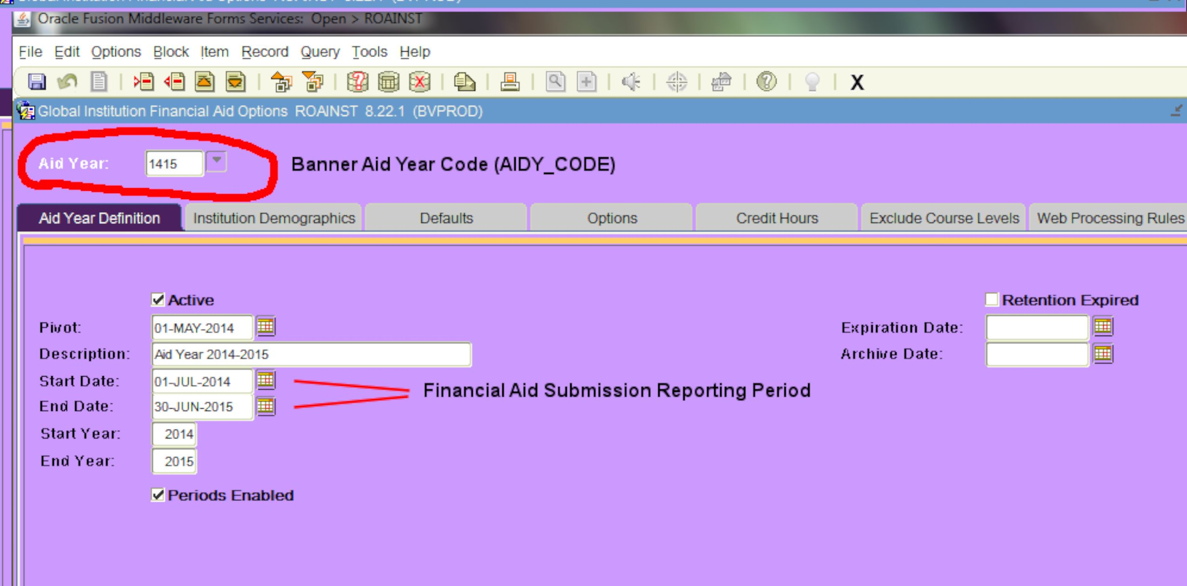

For the institutions I have contacted, the Banner aid years have all started on July 1st, and all ended on June 30th of the next year (they have even used the same value – “1415” – as their Banner Aid Year code).

Even if an institution’s Start Date, End Date, and Aid Year code differs from the example above, the financial aid reporting for the September, 2015 HEPC submission will be based on the reporting period as defined in each institutions Banner ROAINST form.
The financial aid reported for students will still be broken out by the semester in which it was awarded, but those reporting semesters will be based on the semesters each institution defines as part of its financial aid year (see your Banner ROIPRDS or ROITERM forms to see which semesters are part of your Banner financial aid year – examples below).

To provide consistency in financial aid reporting at the HEPC level, the new “student submission year” field will be used in conjunction with the (now re-named) “student submission semester” field to indicate which HEPC Student submission file contained the student whose aid is being reported on that line in the Financial Aid submission file.

The example below shows an institution with three term codes defined in their “1415” aid year, as shown in their Banner ROIPRDS form: 201501, 201502, and 201503 (this is an example of an institution that uses a “trailing” summer for financial aid disbursement).

Those semesters represent the period for which this institution is expected to report financial aid paid to students in their financial aid file submission due 9/15/2015 (what the HEPC calls the “2014 Financial Aid Year”).

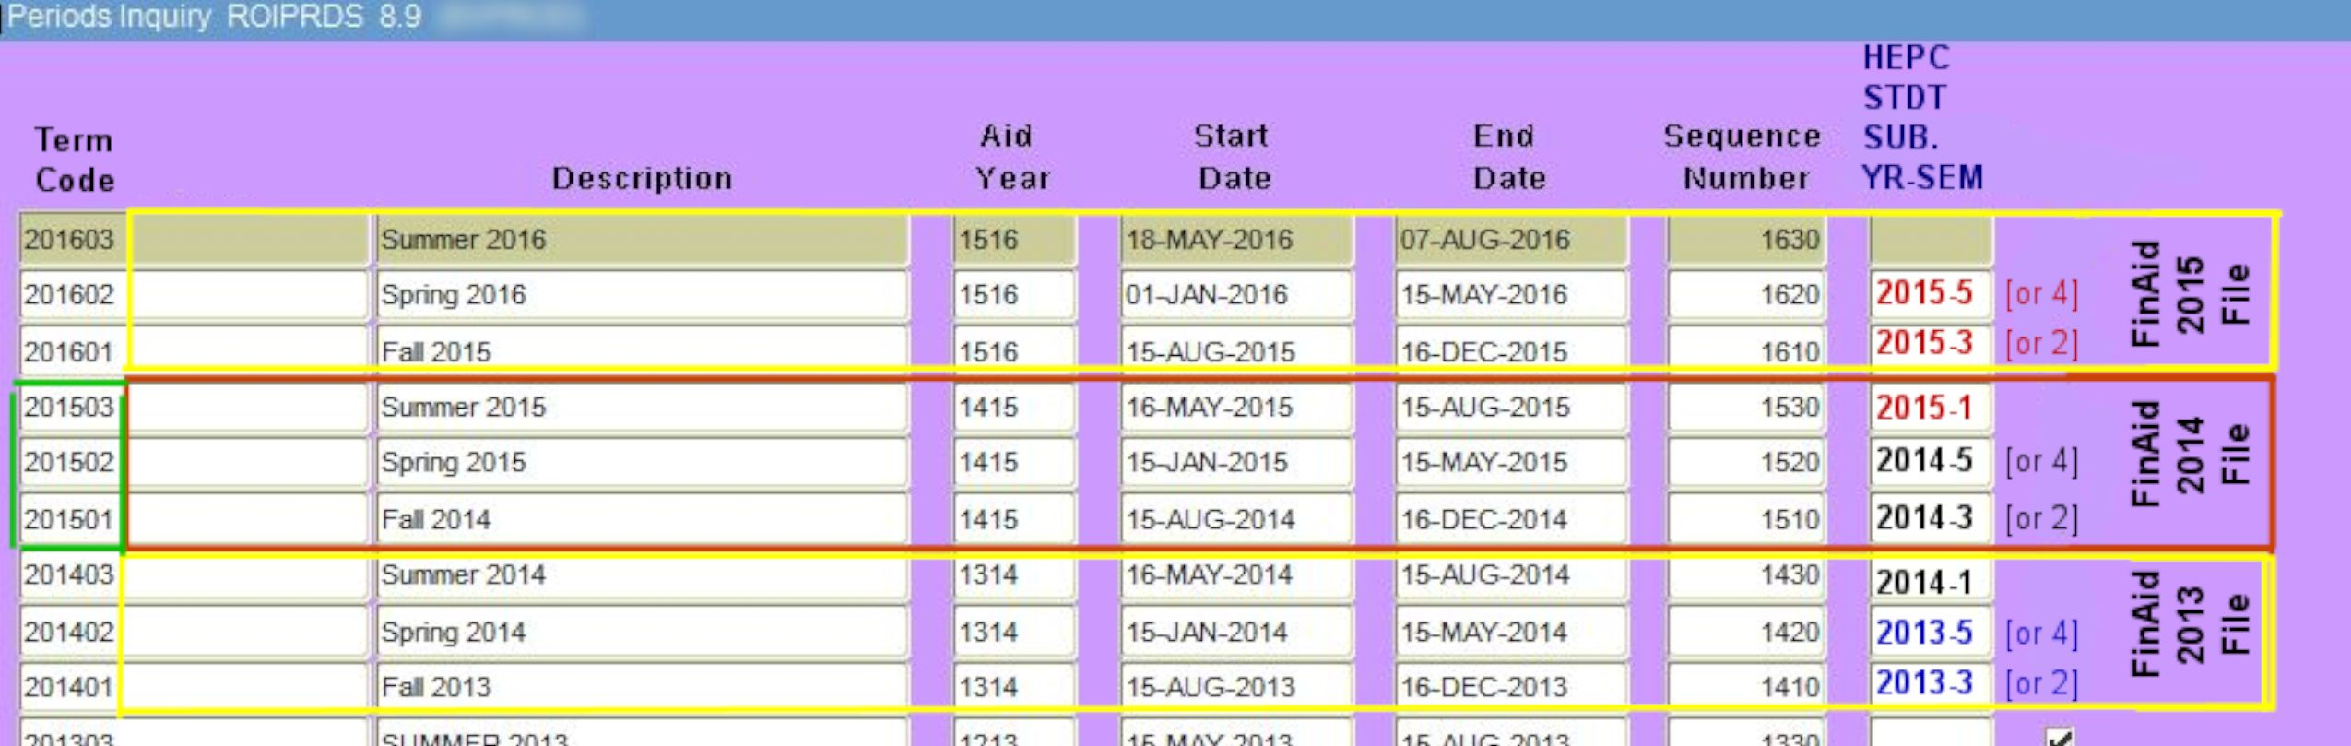
The additional information that we are requesting in the upcoming financial aid submission file, the “student submission year” and “student submission semester” is the HEPC year and semester that the student who was paid financial aid for that term was included in the Student file submission.

For fall and spring semesters, use the end-of-term semester number (3 or 5), unless the student was reported in the census submission and not in the end of term submission.

(Note: if a student was given financial aid but did not attend the institution that semester – and there are codes for this in field 43 (“Non-enrolled Student Code) of the financial aid submission file – enter the student submission year and semester that the student would have been reported in a Student submission file)

Using the chart above, if a student received financial aid in all Banner terms (201501, 201502, and 201503), that student would have three lines in the financial aid submission file. The line with the aid the student received in term 201501 would use “2014” and “3” (or 2) as the student submission year and semester; the line with the aid for term 201502 would use “2014” and “5” (or 4) as the student submission year and semester; and line with aid for the term 201503 would use “2015” and “1” as the student submission year and semester.
Some institutions use “leading” summers for their financial aid disbursement in a given Banner Aid Year, and some institutions disburse in both the leading and trailing summers. By using the Banner Aid Year code as the reporting period for the financial aid submission file, and by providing the student submission year and semester in each students line(s) in that file, it does not matter whether institutions' summer terms are leading, trailing, or both.

Students who are reported in the Financial Aid submission file – and do not have one of the valid Non-Enrolled Student Codes in field 43 – will have a corresponding entry in a Student submission file previously provided by the institution.

The following graphic shows an example of an institution with both leading and trailing summers:

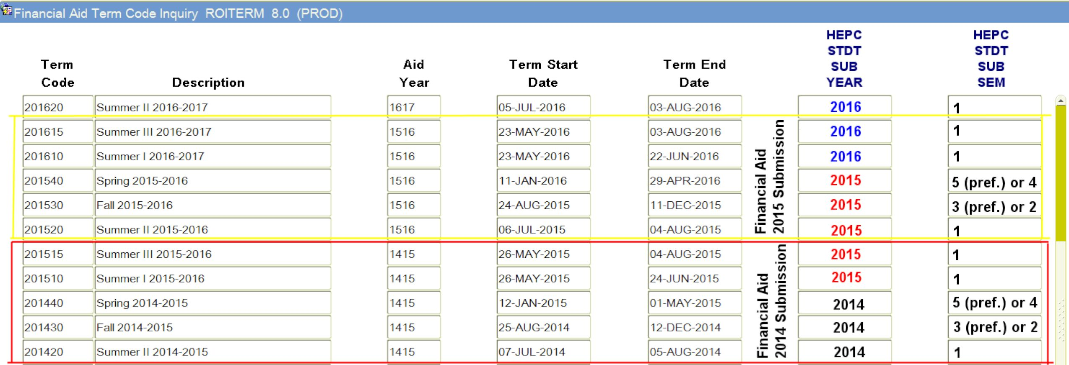
In this example, students who were awarded financial aid in the 201420 term would have been included in the Student file with year and semester designation “2014” and “1”. For the 201430 term, the Student file year and semester would be “2014” and “3” (or “2”, if the student was in the census Student submission but not the end-of-term submission). For the 201440 term, the Student file year and semester would be “2014” and “5” (or “4” if the student was in the census Student submission but not the end-of-term submission).

For this particular institution, the only complications are the two summer trailing terms, 201510 and 201515. The financial aid students received in these terms needs to be combined, because these students are reported in a single Student submission file (year “2015” and semester “1”).

Institutions should be able to “map” their Banner Aid Year term codes to HEPC Student file reporting year and semester values, with the only exceptions being students who were given financial aid in a fall or spring term who were not included in that institution’s end-of-term submissions.

In closing, please do not hesitate to contact me if you have any questions. We know this change may pose a challenge with the upcoming deadline and the Commission is willing to help in any way we can.

Thank you.

