 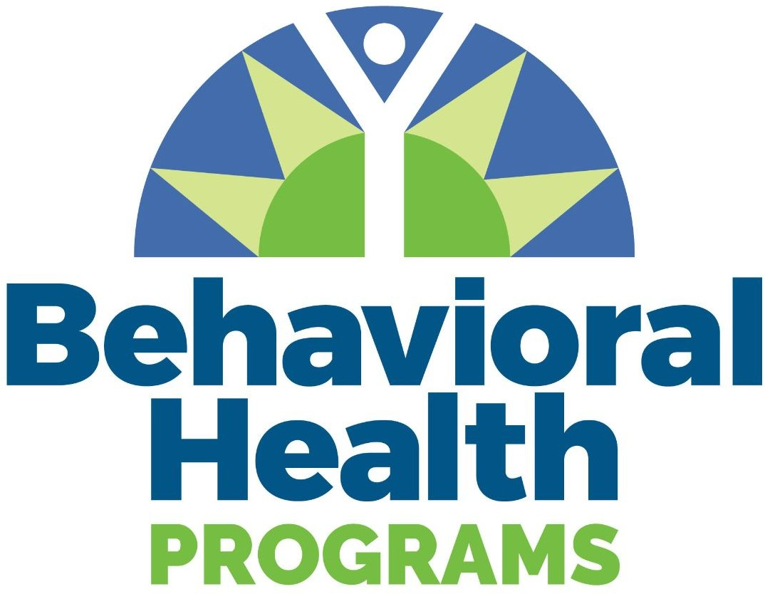

**2023-2024 Four-year Colleges and Universities**

**Campus Mental Health Grant**

**Request for Proposals**

**Submission Deadline: Friday June 30, 2023, by 5:00pm**

Purpose

Under this competitive grant process, funds will be awarded to public 4-year colleges and universities and campus or community based organizations that directly serve college students and that meet the eligibility requirements. Project activities will be directed at improving student mental health on college campuses through implementation of evidence based programming and best practices addressing one or more of the areas below as recommended by the American Council on Education.

1. Assess existing mental health services and identify gaps.
2. Enhance the accessibility of clinical services.
3. Integrate mental health promotion and prevention throughout the campus system.
4. Establish a campus-wide culture that strives to identify, prevent, and treat mental illness through proactive messaging, communication, and norm setting.

Applicants are encouraged to partner with existing resources on campus and in the community, including health centers, counseling centers, counseling, psychology, social work or other human services academic departments, regional prevention lead organizations, recovery support and community mental health agencies, as well as other 2- and 4-year colleges or universities providing training and tools for students, faculty, and staff. Examples of potential projects include: increasing availability of mental health and substance misuse prevention materials and programs for students, implementing or strengthening connection, resilience or recovery support programming for students, supporting student-led mental health initiatives, providing mental health training for faculty, staff and students, evaluating or developing campus wide mental health policies and plans, increasing access to services that address food insecurity, housing insecurity, recovery, or clinical counseling needs of students.

The opportunity is managed by the Division of Health Sciences at the West Virginia Higher Education Policy Commission and is a project of the Behavioral Health Programs Campus Mental Health initiatives designed to address mental health needs of students on West Virginia’s public institutions of higher education. Requests up to $5,000 will be accepted for review. Five projects will be funded through this opportunity. The award period will be detailed in the agreement for funds. Funding is contingent on agency budget approval.

## Dates and Transmittal

To be considered for the Campus Mental Health Grant, your application/proposals are to be submitted through the grant application portal by 5:00 p.m., June 30, 2023. The initial review will begin after June 30, 2023. **All applications for funding will be received via the** [**WV HEPC Health Sciences Grants Portal**](https://hsgrants.force.com/)**. No late applications will be accepted.**

## Eligibility Requirements

West Virginia public four-year colleges and campus-based or community-based organizations that directly and primarily serve college students are eligible to apply.

## Institutional Grant Protocol

It is important that the applicant coordinate with the institution’s advancement office before submitting a grant application.

## Estimated Range of Awards

The amount of an award under the RFP will depend upon the quality of the application and the amount of funds allocated to support this category. Institutions are encouraged to seek external funding sources and engage in cooperative arrangements with public and private entities to enhance funding. The maximum single award during FY 2024 will not exceed $5,000. A total of approximately $60,000 in grants will be awarded.

## Requirements

## Awardees will be required to adhere to the following:

## 1. Awardees must complete and execute an agreement for funds prior to release of any funds. Award agreements will be sent to the signatory authority via SignNow. Only agreements signed and returned via SignNow will be accepted.

## 2. Awardees must invoice for grant funds. Invoicing will occur within the portal.

## 3. Awardees must complete a final report. Final reports will require a narrative and budget update on program activities. Reporting will occur within the portal.

## 4. Awardees must return any unused funds from this award at the end of the specified performance period.

## 5. Indirect costs are not a chargeable expense.

## Reporting Requirements

Each funded institution will submit to the West Virginia Higher Education Policy Commission or West Virginia Council for Community and Technical College Education the required Campus Mental Health Grant end of year program report. This report is designed to capture sponsored programming information, event objectives, evaluation of sponsored events, and end-of-year expenditure information. Reports must be submitted through the Health Sciences Grant Portal.

**Application and Submission Information**

Applications for funding will be received via the WV HEPC Health Sciences Grants portal.

A. Exhibit A- Activity Overview/Statement of Work (links to templates provided in the portal)

B. Exhibit B- Project Budget & Budget Justification (links to templates provided in the portal)

**Statement of Work:**

* + Provide a brief summary of major project components and planned activities. Include an explanation of how the proposed initiative addresses the Campus Mental Health Grant objectives.
  + Describe the method of evaluation that will be used to measure the outcomes of the project activities.
  + Describe the sustainability plan for this effort once this grant has been expended.
  + Complete the SMART Goals table to describe the project goals, activities, outcomes and timeline. See<https://www.samhsa.gov/sites/default/files/nc-smart-goals-fact-sheet.pdf>for a helpful review of creating SMART goals.

|  |  |  |  |
| --- | --- | --- | --- |
| **Project SMART Goals** | **Activities to meet goals** | **Anticipated outcome** | **Time for completion of goal** |
|  |  |  |  |
|  |  |  |  |
|  |  |  |  |
|  |  |  |  |
|  |  |  |  |

Note: Institutions submitting more than one application must provide a priority ranking of applications with 1 being the highest.

**Project Budget:**

* + Include costs and justification for each line item. Note: Indirect costs are not permitted.

|  |  |  |
| --- | --- | --- |
| **Expense Categories** | **Budget** | **Budget Justification** |
| Salaries and Benefits |  |  |
| Contractual |  |  |
| Hospitality |  |  |
| Supplies |  |  |
| Rent |  |  |
| Travel |  |  |
| Stipends |  |  |
| Miscellaneous |  |  |
| Total |  |  |

Thank you for your interest in the Campus Mental Health Grant opportunity. Should you have any questions, please contact: Carolyn Canini

Director of Behavioral Health Programs

West Virginia Higher Education Policy Commission

West Virginia Council for Community & Technical College Education [carolyn.canini@wvhepc.edu](mailto:carolyn.canini@wvhepc.edu)