West Virginia Higher Education Policy Commission Health Sciences Division
Applying for and Managing a Grant using the Health Sciences Division Grants Portal

User Guide

Applying for and Managing a Grant using the

Health Sciences Grants Portal

Welcome to the Health Sciences Grants Portal, your one stop to apply for and manage all grant functions including applications, reports, invoices, and change orders.
Prior to registering for the portal, please make sure that your organization is registered in OASIS, West Virginia’s fiscal management system. If your organization is not registered in OASIS, your organization will need to register by visiting http://www.state.wv.us/admin/purchase/vendorreg.html. You should also register to receive electronic payments from the state at the same time if you have not already done so.

Registering as a User in the Health Sciences Grants Portal

You must register in the Health Sciences Grants Portal in order to use the Grants Portal. Please go to https://HSGrants.force.com and register your organization and yourself as a user. You will see a screen like this each time you visit the site. 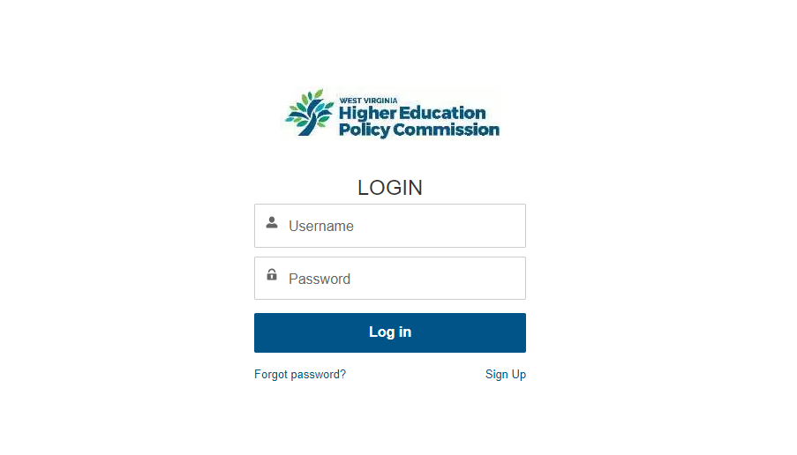On your first visit, you will register by clicking on Sign Up in the lower right corner. You will need to provide information about your organization on this page and your contact information. You need to enter your organization name, address, and OASIS vendor ID number exactly as it is found in the state’s OASIS system. If you are with a college or university and will be using a Research Corporation to receive and manage your grant funding, please list the Research Corporation as your organization and their vendor ID number to ensure that your grant funds will be sent to the correct entity.
In the grants portal, you will also register your name and email address and set a password. You will use this information each time you log in to the account after registering. Please do not share your user id and password. Each user of the system should register themselves and have their own credentials. The Applicant Organization name and vendor ID will link you all to the correct applications.
Once you are a registered user you can view open grant opportunities or view opportunities for which you’ve been invited to apply.

Applying for a Grant using the Health Sciences Grants Portal

Once you have logged into the system as a registered user, you will find an introductory page that will review our grant making priorities. You will then click on Apply for a Grant. You will see a list of open funding programs. Please click on the applicable program and you will see an overview of the opportunity. Please read the opportunity guidance. You may then click on Create a Funding Request in the upper right corner of the page. You must have POP UP blockers turned off.
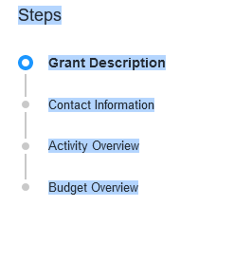
You will see the steps for application that look like the screen shot below. These steps will appear on each page and will track your progress.

You will see a grant description with application deadlines and other details. Click NEXT. You will go to the CONTACT INFORMATION page. Much of this information will be pre-populated from your registration. You are listed as the Grant Manager. On this page you will need to add the first and last name of the person in your organization who is authorized to sign grant applications (authorized signatory). You will add their email address and their phone number here. If there are other contacts for your grant click on the box that says “Do you want to create other contact for your Funding Request?” and you will have the ability to add other team members like a business manager for example.
If you are a state agency, you must enter your OASIS IET Funding String number here. This is very important as it will allow us to provide your funds through electronic transfer and allow you to access your funds more quickly. Please enter this information here. If you are not sure what this number is, please check with your business office. You can then click NEXT.
This page will bring you to your ACTIVITY OVERVIEW. You will upload your statement of work here. You will see the following with the link to the form to use for this statement of work.
Navigate to the Grants Portal Forms section of our website to download the necessary file templates.
Click on the our website link and you will find the forms on the HEPC Health Sciences website. You can fill them out as usual and upload them into the portal. To assure that you complete the correct forms, you will either choose a Small Grant or a Large Grant. Large Grants are only for our three academic medical schools who receive large grants appropriated by the legislature as part of the Rural Health Initiative. Unless you are one of those schools applying for those grants you will choose small grants. You will need to complete Exhibit A, Statement of Work for this upload to the portal. When complete, save the document to your computer, and upload into the portal by clicking UPLOAD.
Click NEXT and you will be brought to the budget page. Again, navigate to the our website link and you will find Exhibit B, Budget and Budget Justification. After you fill out these documents, save to your computer and upload to the portal by clicking UPLOAD.
When you are finished entering the budget, please click SUBMIT and your Funding Request will be complete and submitted for our review. If you check back on the portal, your application status will change as it moves through the review and approval process. It may say submitted, under review, needs revision, or approved. If you need revisions, a member of our staff will contact you to review the revisions required.
At any time if you need to leave the portal, you can press the Save for Later button on any page and come back to your work.
If your application is approved for funding you will receive additional information at that time including a Grant Agreement. The Notice of Grant Award will be sent for signature to your Authorized Signatory who you entered into your organizational profile during the registration process. This NGA will arrive via Sign Now. It should be reviewed and signed as soon as possible. You will not be able to begin any grant activities until the NGA is fully executed.

What’s Next?

Once your NGA is fully executed you may begin grant activities.

Invoices

Invoices can be submitted based on the Program Announcement guidelines. Some grants may require one invoice, others may have invoices spread over the period of a year. Please check your Program Announcement to be sure about invoicing guidelines.

After logging in, click the Grant Agreement tab from the top navigation bar, then click on the link on the left, which will be your assigned grant agreement number, as shown below.

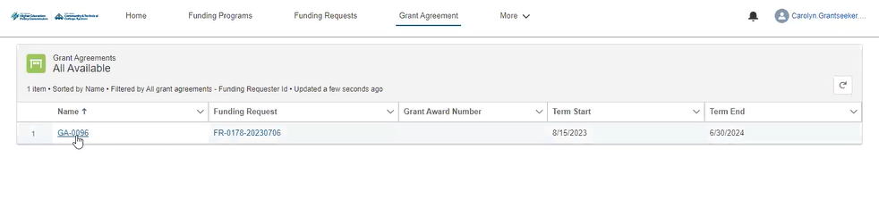
On the next page, you will see two tabs- the DETAILS tab and the RELATED tab. Click on RELATED.

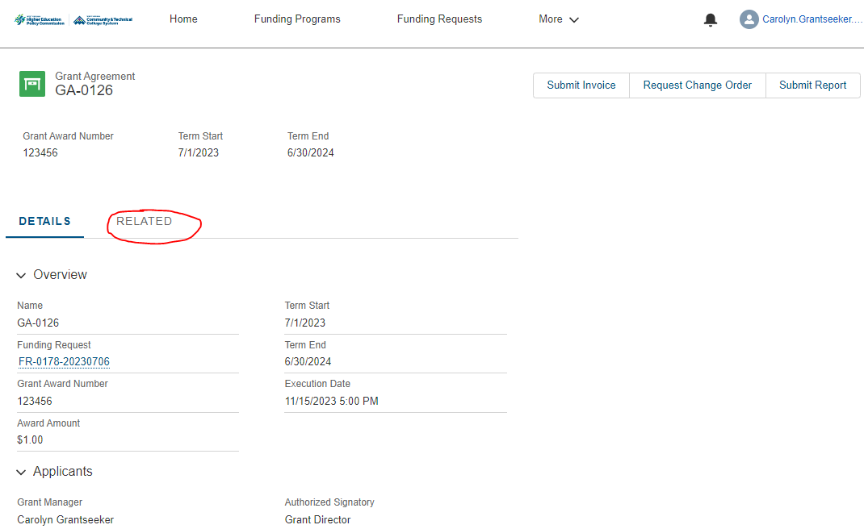

On the next page, you will see your available disbursements. Click on the blue highlighted disbursement number for your award under the disbursements heading.
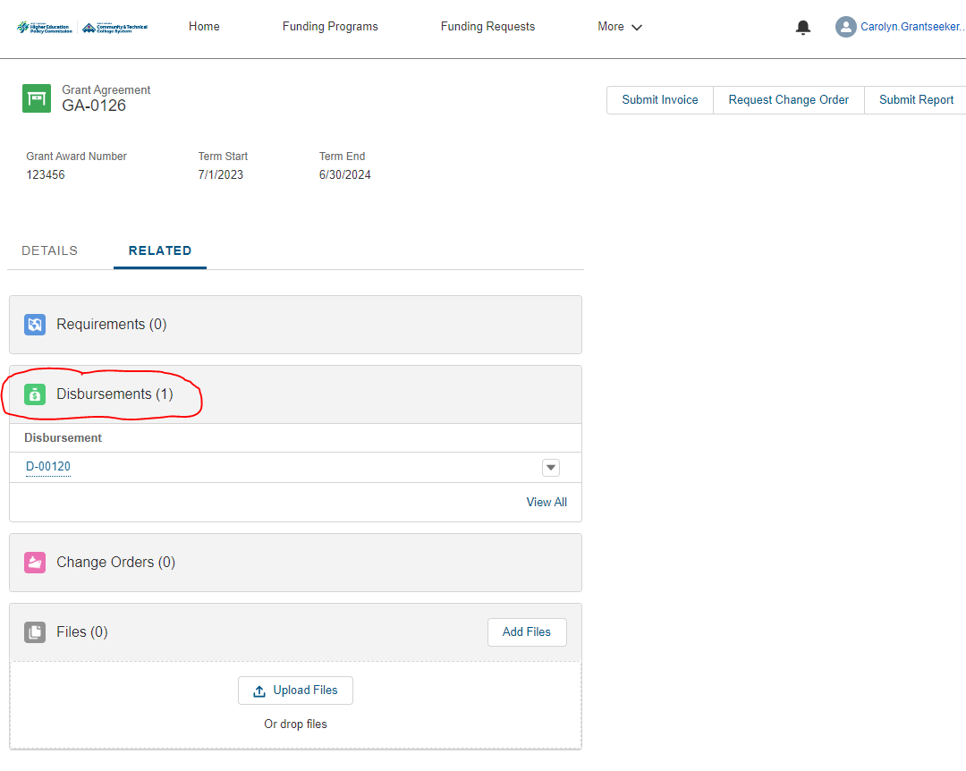
On the next screen, click on the RELATED tab.
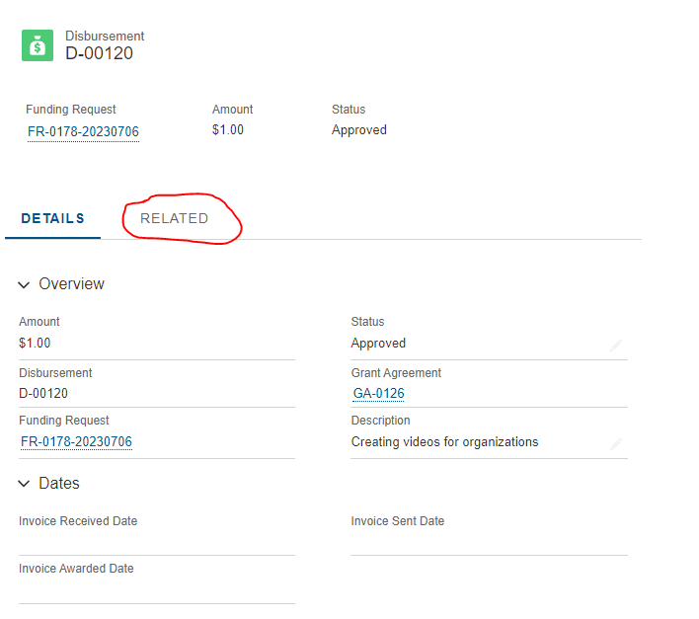
On this page you will be able to select your invoice file from your computer by clicking Upload Files, then click Submit. The invoice template is available here: https://www.wvhepc.edu/inside-the-commission/offices-and-affiliates/health-sciences/
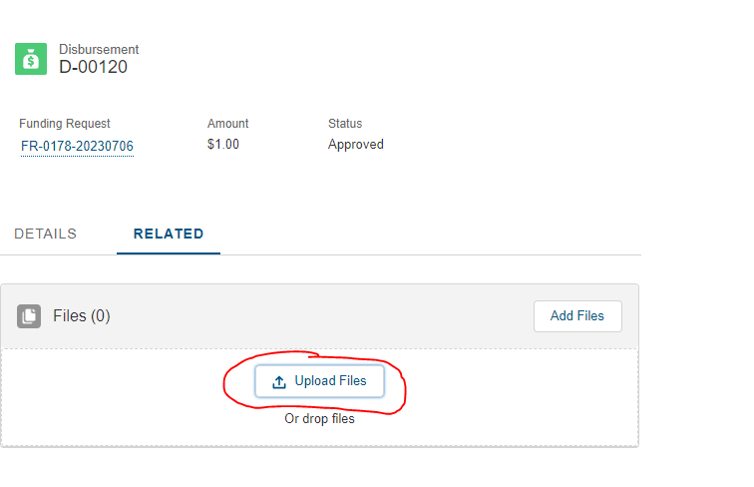

Reports

Most grants will require a mid-term and final report. Guidance for due dates for these reports is in your Program Announcement. Please be sure to submit your reports through the portal by the due date. Any feedback will be provided via email.
To upload a mid-term or final report, click on Grant Agreement from the top navigation menu, then click the blue highlighted grant agreement number in the left column. The next screen will have a Submit Report button in the top right corner. Click the Submit Report button.
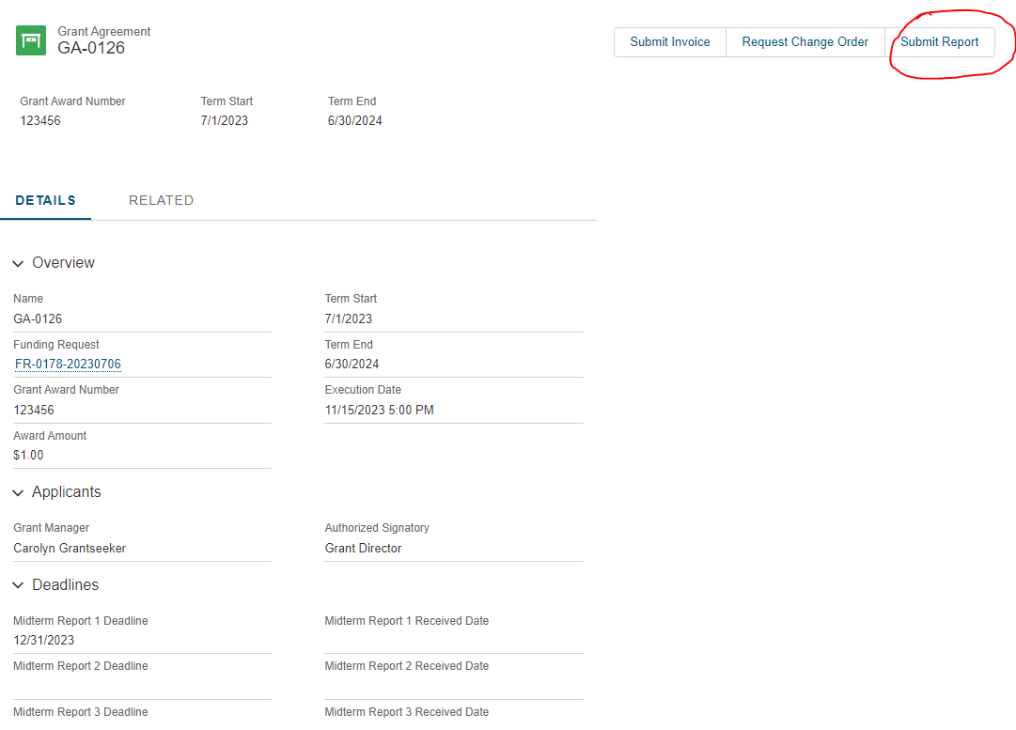

The next screen will provide an overview of your Grant Agreement Info. Click Next.
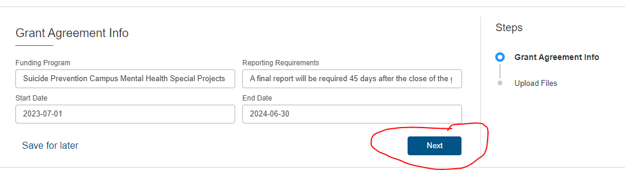

The next screen gives you an opportunity to upload a narrative report and a budget report. Templates for these reports are available on the Grants Portal Forms section of our website: https://www.wvhepc.edu/inside-the-commission/offices-and-affiliates/health-sciences/

Once you have uploaded both files, click Save in the right lower corner.
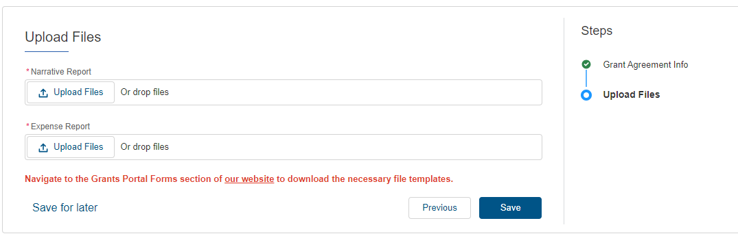

Change Orders

If you require a change order for your grant, you will submit it via the portal. Change orders are required for our grants if:
- A change in the scope of the grant agreement has occurred. A change in scope is a significant change in activity from what was originally described in the statement of work or workplan contained in the grant agreement. An example of a change in scope may include an activity initially budgeted for that can no longer be completed due to unavoidable circumstances and a request for those funds to be redistributed to a new, entirely different activity.
- The project timeline is moving slower than anticipated and the grantee needs additional time to complete the work and/or expend all the project funds (a no cost extension of the end date).
- You wish to transfer more than 10 percent of the total approved budget between expense (and where applicable functional) categories.
- You are requesting a new purchase of equipment that is $1,000.00 or more and was not included in the initial grant request.
- The grantee encounters circumstances necessitating that it terminate the agreement. In addition, if you wish to change the project director you will need to request a change order.
To request a change order, you will complete the change order request found in the portal. Once the change order request has been received it will be reviewed and if approved, a change order will be generated. This change order will be sent via Sign Now to your authorized signatory for signature. Please alert them to the expected change order. Once the change order has been fully executed you will be able to make the change.
To submit a change order request, you will follow the same steps above for submitting a report, except you will select the button for Request Change Order instead of Submit Report. No attachments are required for a change order request. You will type your request information directly into the provided fields and click submit.

Need Help or Have Questions?

If you have any questions during your grant application, please reach out to the contact for your funding program.
For Large Rural Health Initiative Grants and Special Projects Grants, please contact Deloris Vance at Deloris.vance@wvhepc.edu or the staff member who invited you to submit the grant application.
For Nursing Academy Grants and Nursing Expansion Grants, please contact Jordyn Reed at jordyn.reed@wvhepc.edu
For Campus Mental Health and Behavioral Health Initiative Grants, please contact Carolyn Canini at Carolyn.canini@wvhepc.edu
For all business and grants operations questions, please contact Deloris Vance at Deloris.vance@wvhepc.edu

